**General Questions – Spring Interview Questions**

**1. What are the major features in different versions of Spring Framework?**

|  |  |  |
| --- | --- | --- |
| **Version** | **Logo** | **Feature** |
| **Spring 2.5** | spring 2.5 logo - Spring Interview Questions - Edureka! | This version was released in 2007. It was the first version which supported annotations. |
| **Spring 3.0** | spring 3.0 logo - Spring Interview Questions - Edureka! | This version was released in 2009. Itmade full-fledged use of improvements in Java5 and also provided support to JEE6. |
| **Spring 4.0** | Spring 4.0 logo - Spring Interview Questions - Edureka! | This version was released in 2013. This was the first version to provide full support to Java 8. |

**2. What is a Spring Framework?**

* Spring is a powerful open source, application framework created to reduce the complexity of enterprise application development.
* It is light-weighted and loosely coupled.
* It has layered architecture, which allows you to select the components to use, while also providing a cohesive framework for J2EE application development.
* Spring framework is also called the framework of frameworks as it provides support to various other frameworks such as Struts, Hibernate, Tapestry, EJB, JSF etc.

**3. List the advantages of Spring Framework.**

* Because of Spring Frameworks layered architecture, you can use what you need and leave which you don’t.
* Spring Framework enables POJO (Plain Old Java Object) Programming which in turn enables continuous integration and testability.
* JDBC is simplified due to Dependency Injection and Inversion of Control.
* It is open-source and has no vendor lock-in.

**4. What are the different features of Spring Framework?**

Following are some of the major features of Spring Framework :

* **Lightweight:** Spring is lightweight when it comes to size and transparency.
* **Inversion of control (IOC):** The objects give their dependencies instead of creating or looking for dependent objects. This is called Inversion Of Control.
* **Aspect oriented Programming (AOP):** Aspect oriented programming in Spring supports cohesive development by separating application business logic from system services.
* **Container:**Spring Framework creates and manages the life cycle and configuration of the application objects.
* **MVC Framework:** Spring Framework’s MVC web application framework is highly configurable. Other frameworks can also be used easily instead of Spring MVC Framework.
* **Transaction Management:** Generic abstraction layer for transaction management is provided by the Spring Framework. Spring’s transaction support can be also used in container less environments.
* **JDBC Exception Handling:** The JDBC abstraction layer of the Spring offers an exception hierarchy, which simplifies the error handling strategy.

**5. How many modules are there in Spring Framework and what are they?**

There are around 20 modules which are generalized into Core Container, Data Access/Integration, Web, AOP (Aspect Oriented Programming), Instrumentation and Test.

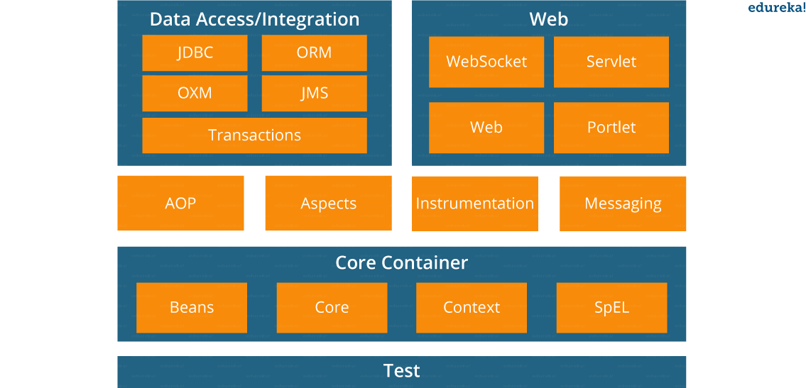

* **Spring Core Container –**This layer is basically the core of Spring Framework.It contains the following modules :

1. Spring Core
2. Spring Bean
3. SpEL (Spring Expression Language)
4. Spring Context

* **Data Access/Integration –**This layer provides support to interact with the database. It contains the following modules :

1. JDBC (Java DataBase Connectivity)
2. ORM (Object Relational Mapping)
3. OXM (Object XML Mappers)
4. JMS (Java Messaging Service)
5. Transaction

* **Web –**This layer provides support to create web application. It contains the following modules :

1. Web
2. Web – MVC
3. Web – Socket
4. Web – Portlet

* **Aspect Oriented Programming (AOP) –** In this layer you can use Advices, Pointcuts etc., to decouple the code.
* **Instrumentation –**This layer provides support to class instrumentation and classloader implementations.
* **Test –**This layer provides support to testing with JUnit and TestNG.

Few Miscellaneous modules are given below:

* **Messaging –**This module provides support for STOMP. It also supports an annotation programming model that is used for routing and processing STOMP messages from WebSocket clients.
* **Aspects –**This module provides support to integration with AspectJ.

**6. What is a Spring configuration file?**

A Spring configuration file is an XML file. This file mainly contains the classes information. It describes how those classes are configured as well as introduced to each other. The XML configuration files, however, are verbose and more clean. If it’s not planned and written correctly, it becomes very difficult to manage in big projects.

**7. What are the different components of a Spring application?**

A Spring application, generally consists of following components:

* Interface: It defines the functions.
* Bean class: It contains properties, its setter and getter methods, functions etc.
* Spring Aspect Oriented Programming (AOP): Provides the functionality of cross-cutting concerns.
* Bean Configuration File: Contains the information of classes and how to configure them.
* User program: It uses the function.

**8. What are the various ways of using Spring Framework?**

Spring Framework can be used in various ways. They are listed as follows:

1. As a Full-fledged Spring web application.
2. As a third-party web framework, using Spring Frameworks middle-tier.
3. For remote usage.
4. As Enterprise Java Bean which can wrap existing POJOs (Plain Old Java Objects).

The next section of Spring Interview Questions is on *Dependency Injection and IoC container*.

**Dependency Injection/ IoC Container – Spring Interview Questions**

**9. What is Spring IOC Container?**

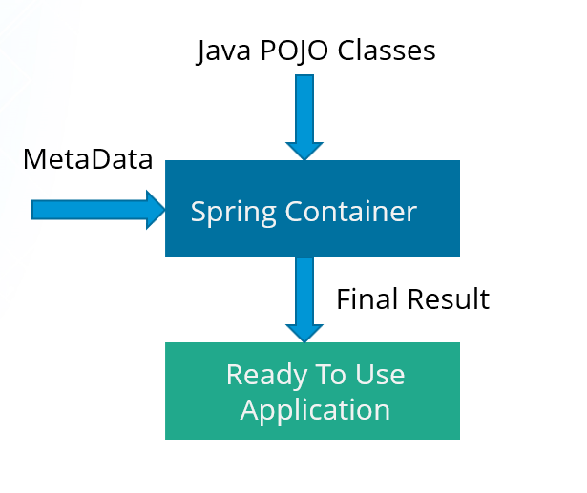

At the core of the Spring Framework, lies the Spring container. The container creates the object, wires them together, configures them and manages their complete life cycle. The Spring container makes use of Dependency Injection to manage the components that make up an application. The container receives instructions for which objects to instantiate, configure, and assemble by reading the configuration metadata provided. This metadata can be provided either by XML, Java annotations or Java code.

**10. What do you mean by Dependency Injection?**

In Dependency Injection, you do not have to create your objects but have to describe how they should be created. You don’t connect your components and services together in the code directly, but describe which services are needed by which components in the configuration file. The IoC container will wire them up together.

**11. In how many ways can Dependency Injection be done?**

In general, dependency injection can be done in three ways, namely :

* Constructor Injection
* Setter Injection
* Interface Injection

In Spring Framework, only constructor and setter injections are used.

**12. Differentiate between constructor injection and setter injection.**

Constructor Injection vs Setter Injection

|  |  |
| --- | --- |
| **Constructor Injection** | **Setter Injection** |
| There is no partial injection. | There can be partial injection. |
| It doesn’t override the setter property. | It overrides the constructor property. |
| It will create a new instance if any modification is done. | It will not create new instance if any modification is done. |
| It works better for many properties. | It works better for few properties. |

**13. How many types of IOC containers are there in spring?**

1. **BeanFactory**: BeanFactory is like a factory class that contains a collection of beans. It instantiates the bean whenever asked for by clients.
2. **ApplicationContext**: The ApplicationContext interface is built on top of the BeanFactory interface. It provides some extra functionality on top BeanFactory.

**14. Differentiate between BeanFactory and ApplicationContext.**

BeanFactory vs ApplicationContext

|  |  |
| --- | --- |
| **BeanFactory** | **ApplicationContext** |
| It is an interface defined in org.springframework.beans.factory.**BeanFactory** | It is an interface defined in org.springframework.context.**ApplicationContext** |
| It uses Lazy initialization | It uses Eager/ Aggressive initialization |
| It explicitly provides a resource object using the syntax | It creates and manages resource objects on its own |
| It doesn’t supports internationalization | It supports internationalization |
| It doesn’t supports annotation based dependency | It supports annotation based dependency |

**15.  List some of the benefits of IoC.**

Some of the benefits of IoC are:

* It will minimize the amount of code in your application.
* It will make your application easy to test because it doesn’t require any singletons or JNDI lookup mechanisms in your unit test cases.
* It promotes loose coupling with minimal effort and least intrusive mechanism.
* It supports eager instantiation and lazy loading of the services.

Let’s move on to the next section of Spring Interview Questions, that is *Spring Beans Interview Questions*.

**Spring Beans – Spring Interview Questions**

**16. Explain Spring Beans?**

* They are the objects that form the backbone of the user’s application.
* Beans are managed by the Spring IoC container.
* They are instantiated, configured, wired and managed by a Spring IoC container
* Beans are created with the configuration metadata that the users supply to the container.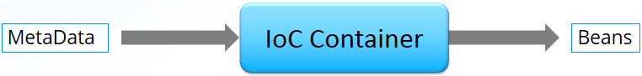

**17. How configuration metadata is provided to the Spring container?**

Configuration metadata can be provided to Spring container in following ways:

* **XML-Based configuration:**In Spring Framework, the dependencies and the services needed by beans are specified in configuration files which are in XML format. These configuration files usually contain a lot of bean definitions and application specific configuration options. They generally start with a bean tag. For example:

|  |  |
| --- | --- |
| 1  2  3 | <bean id="studentbean" **class**="org.edureka.firstSpring.StudentBean">   <property name="name" value="Edureka"></property>  </bean> |

* **Annotation-Based configuration**: Instead of using XML to describe a bean wiring, you can configure the bean into the component class itself by using annotations on the relevant class, method, or field declaration. By default, annotation wiring is not turned on in the Spring container. So, you need to enable it in your Spring configuration file before using it. For example:

|  |  |
| --- | --- |
| 1  2  3  4 | <beans>  <context:annotation-config/>  <!-- bean definitions go here -->  </beans> |

* **Java-based configuration:**The key features in Spring Framework’s new Java-configuration support are @Configuration annotated classes and @Bean annotated methods.

1. @Bean annotation plays the same role as the <bean/> element.

2.@Configuration classes allows to define inter-bean dependencies by simply calling other @Bean methods in the same class.

For example:

|  |  |
| --- | --- |
| 1  2  3  4  5  6  7 | @Configuration  **public** **class** StudentConfig  {  @Bean  **public** StudentBean myStudent()  { **return** **new** StudentBean(); }  } |

**18. How many bean scopes are supported by Spring?**

The Spring Framework supports five scopes. They are:

* **Singleton:**This provides scope for the bean definition to single instance per Spring IoC container.
* **Prototype:**This provides scope for a single bean definition to have any number of object instances.
* **Request:**This provides scope for a bean definition to an HTTP-request.
* **Session:**This provides scope for a bean definition to an HTTP-session.
* **Global-session:**This provides scope for a bean definition to an Global HTTP-session.

The last three are available only if the users use a web-aware ApplicationContext.

**19. What is the Bean life cycle in Spring Bean Factory Container?**

Bean life cycle in Spring Bean Factory Container is as follows:

1. The Spring container instantiates the bean from the bean’s definition in the XML file.
2. Spring populates all of the properties using the dependency injection, as specified in the bean definition.
3. The factory calls setBeanName() by passing the bean’s ID, if the bean implements the BeanNameAware interface.
4. The factory calls setBeanFactory() by passing an instance of itself, if the bean implements the BeanFactoryAware interface.
5. preProcessBeforeInitialization() methods are called if there are any BeanPostProcessors associated with the bean.
6. If an init-method is specified for the bean, then it will be called.
7. Finally, postProcessAfterInitialization() methods will be called if there are any BeanPostProcessors associated with the bean.

To understand it in better way check the below diagram:

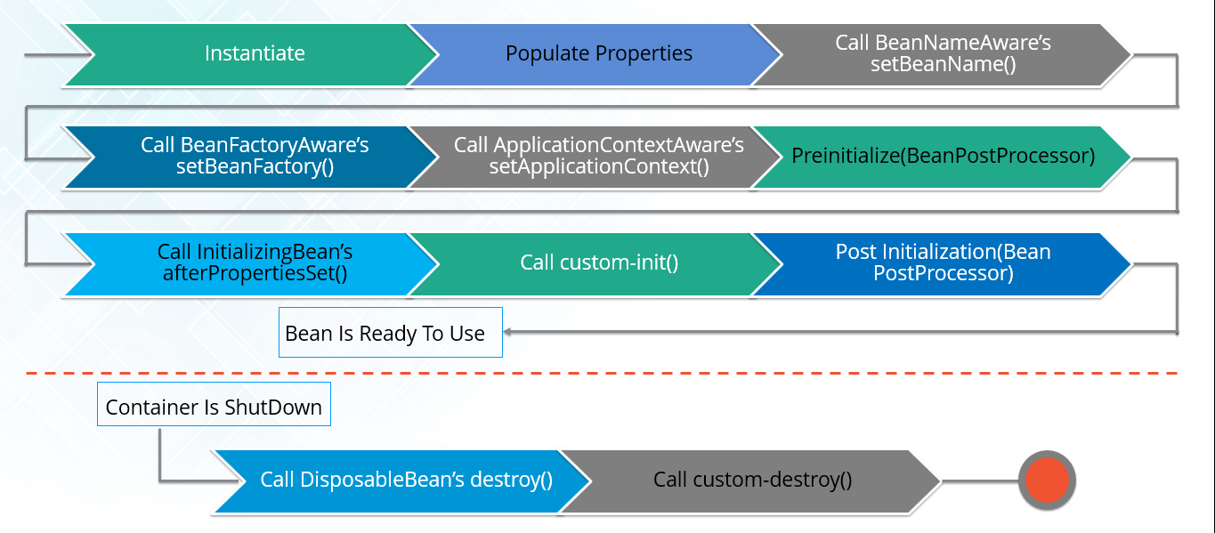

**20. Explain inner beans in Spring.**

A bean can be declared as an inner bean only when it is used as a property of another bean. For defining a bean, the Spring’s XML based configuration metadata provides the use of <bean> element inside the <property> or <constructor-arg>. Inner beans are always anonymous and they are always scoped as prototypes. For example, let’s say we have one Student class having reference of Person class. Here we will be creating only one instance of Person class and use it inside Student.

Here’s a Student class followed by bean configuration file:

Student.java

|  |  |
| --- | --- |
| 1  2  3  4  5  6  7  8  9  10  11 | **public** **class** Student  {  **private** Person person;  //Setters and Getters  }  **public** **class** Person  {  **private** String name;  **private** String address;  //Setters and Getters  } |

studentbean.xml

|  |  |
| --- | --- |
| 1  2  3  4  5  6  7  8  9 | <bean id=&ldquo;StudentBean" class="com.edureka.Student">  <property name="person">  <!--This is inner bean -->  <bean **class**="com.edureka.Person">  <property name="name" value=&ldquo;Scott"></property>  <property name="address" value=&ldquo;Bangalore"></property>  </bean>  </property>  </bean> |

**21. Define Bean Wiring.**

When beans are combined together within the Spring container, it’s called wiring or bean wiring. The Spring container needs to know what beans are needed and how the container should use dependency injection to tie the beans together, while wiring beans.

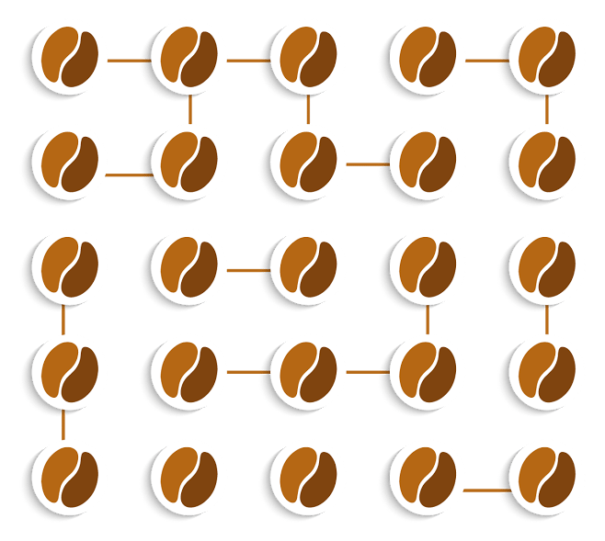

**22. What do you understand by auto wiring and name the different modes of it?**

The Spring container is able to autowire relationships between the collaborating beans. That is, it is possible to let Spring resolve collaborators for your bean automatically by inspecting the contents of the BeanFactory.  
Different modes of bean auto-wiring are:

1. **no:** This is default setting which means no autowiring. Explicit bean reference should be used for wiring.
2. **byName:** It injects the object dependency according to name of the bean. It matches and wires its properties with the beans defined by the same names in the XML file.
3. **byType:**It injects the object dependency according to type. It matches and wires a property if its type matches with exactly one of the beans name in XML file.
4. **constructor:**It injects the dependency by calling the constructor of the class. It has a large number of parameters.
5. **autodetect:**First the container tries to wire using autowire by *constructor*, if it can’t then it tries to autowire by *byType*.

**23. What are the limitations with auto wiring?**

Following are some of the limitations you might face with auto wiring:

* **Overriding possibility:**You can always specify dependencies using <constructor-arg> and <property> settings which will override autowiring.
* **Primitive data type:**Simple properties such as primitives, Strings and Classes can’t be autowired.
* **Confusing nature:**Always prefer using explicit wiring because autowiring is less precise.

In the next section, we will discuss on *Spring Annotations Interview Questions*.

**Spring Annotations – Spring Interview Questions**

**24. What do you mean by  Annotation-based container configuration?**

Instead of using XML to describe a bean wiring, the developer moves the configuration into the component class itself by using annotations on the relevant class, method, or field declaration. It acts as an alternative to XML setups. For example:

|  |  |
| --- | --- |
| 1  2  3  4  5  6  7 | @Configuration  **public** **class** AnnotationConfig  {  @Bean  **public** MyDemo myDemo()   { **return** **new** MyDemoImpll(); }  } |

**25. How annotation wiring can be turned on in Spring?**

By default, Annotation wiring is not turned on in the Spring container. Thus, to use annotation based wiring we must enable it in our Spring configuration file by configuring **<context:annotation-config/>** element. For example:

|  |  |
| --- | --- |
| 1  2  3  4 | <beans xmlns="<http://www.springframework.org/schema/beans>" xmlns:xsi="<http://www.w3.org/2001/XMLSchema-instance>" xmlns:context="<http://www.springframework.org/schema/context>">  <context:annotation-config/>  <beans &hellip;&hellip;&hellip;&hellip; />  </beans> |

**26. What’s the difference between @Component, @Controller, @Repository & @Service annotations in Spring?**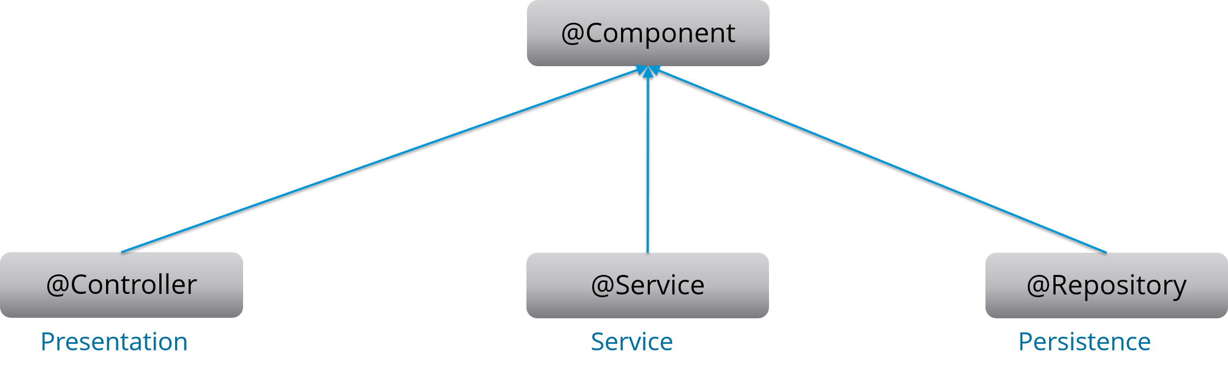

**@Component:** This marks a java class as a bean. It is a generic stereotype for any Spring-managed component. The component-scanning mechanism of spring now can pick it up and pull it into the application context.

**@Controller:** This marks a class as a Spring Web MVC controller. Beans marked with it are automatically imported into the Dependency Injection container.

**@Service:** This annotation is a specialization of the component annotation. It doesn’t provide any additional behavior over the @Component annotation. You can use @Service over @Component in service-layer classes as it specifies intent in a better way.

**@Repository:** This annotation is a specialization of the @Component annotation with similar use and functionality. It provides additional benefits specifically for DAOs. It imports the DAOs into the DI container andmakes the unchecked exceptions eligible for translation into Spring DataAccessException.

**27. What do you understand by @Required annotation?**

@Required is applied to bean property setter methods. This annotation simply indicates that the affected bean property must be populated at the configuration time with the help of an explicit property value in a bean definition or with autowiring. If the affected bean property has not been populated, the container will throw BeanInitializationException.

For example:

|  |  |
| --- | --- |
| 1  2  3  4  5  6  7  8  9 | **public** **class** Employee  {  **private** String name;  @Required  **public** **void** setName(String name)  {**this**.name=name; }  **public** string getName()  { **return** name; }  } |

**28. What do you understand by @Autowired annotation?**

The **@Autowired** annotation provides more accurate control over where and how autowiring should be done. This annotation is used to autowire bean on the setter methods, constructor, a property or methods with arbitrary names or multiple arguments. By default, it is a type driven injection.

For Example:

|  |  |
| --- | --- |
| 1  2  3  4  5  6  7  8  9 | **public** **class** Employee  {  **private** String name;  @Autowired  **public** **void** setName(String name)  {**this**.name=name; }  **public** string getName()  { **return** name; }  } |

**29. What do you understand by @Qualifier annotation?**

When you create more than one bean of the same type and want to wire only one of them with a property  you can use the **@Qualifier** annotation along with **@Autowired** to remove the ambiguity by specifying which exact bean should be wired.

For example, here we have two classes, Employee and EmpAccount respectively. In EmpAccount, using @Qualifier its specified that bean with id emp1 must be wired.

Employee.java

|  |  |
| --- | --- |
| 1  2  3  4  5  6  7  8  9 | **public** **class** Employee  {  **private** String name;    @Autowired  **public** **void** setName(String name) {  **this**.name=name;  }  **public** string getName() {  **return** name;  }  } |

EmpAccount.java

|  |  |
| --- | --- |
| 1  2  3  4  5  6  7  8  9  10 | **public** **class** EmpAccount  {  **private** Employee emp;  @Autowired  @Qualifier(emp1)  **public** **void** showName()  {  System.out.println(&ldquo;Employee name : &rdquo;+emp.getName);  }  } |

**30.  What do you understand by @RequestMapping annotation?**

@RequestMapping annotation is used for mapping a particular HTTP request method to a specific class/ method in controller that will be handling the respective request. This annotation can be applied at both levels:

* **Class level**: Maps the URL of the request
* **Method level**: Maps the URL as well as HTTP request method

Next section of Spring Interview Questions is on *Data Access*.

**Data Access – Spring Interview Questions**

**31. Describe Spring DAO support?**

The Data Access Object (DAO) support in Spring makes it easy to work with data access technologies like JDBC, Hibernate or JDO in a consistent way. This allows one to switch between the persistence technologies easily. It also allows you to code without worrying about catching exceptions that are specific to each of these technology